# Lab 1b: HTML Hyperlinks and semantic elements

Goal of this lab : Understand and practice HTML hyperlinks and HTML5 semantic elements.

## Development Tool:

Use Visual Studio Code + Google chrome.

## Steps:

1. Open the starting code for “lab 01b”.
2. Replace the existing div elements by the appropriate HTML5 semantic elements. Create a different section/article for each lower-level heading and its content.

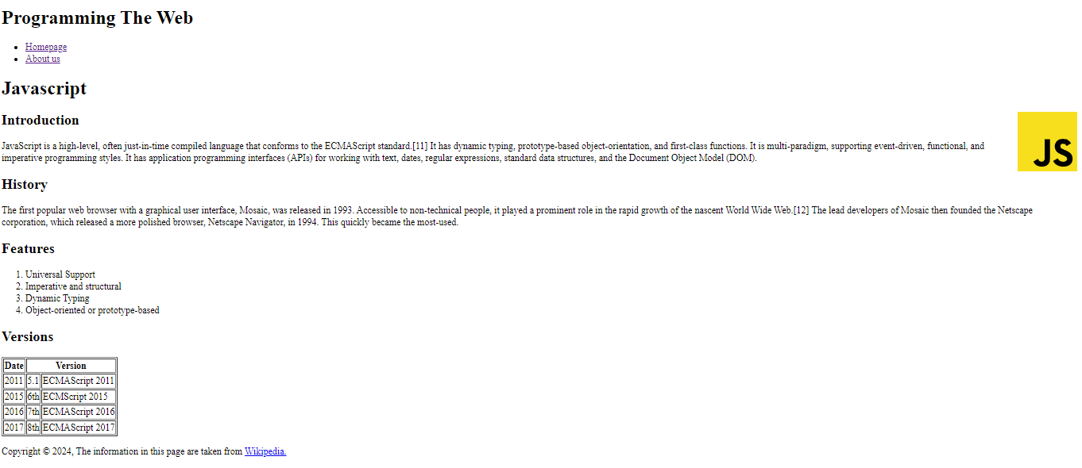

1. Add a hyperlink to the external website in the footer (Wikipedia page for example).
2. Create a second page “about-us.html” in the same folder of your project.
3. Create a menu in both files to navigate between the two pages.
4. In index.html add an outline of the page with links that point to each paragraph (Introduction, History, Features, Versions).
5. In the footer, add a mailto hyperlink that users can use to send you an email with a specified subject. (<a href=”mailto:someemail@domain.com?subject=Email Subject“>SomeText</a>)
6. When we click the image, we want to open the page (https://www.javascript.com/).

End